PatchID: An Overfitting Patches Identification

Method for Automated Program Repair

Byline: Xuanzhou

**Original Corresponding Author:**  
**Name:** _____Xuanzhou______

**Mailing Address:** School of Computer Science, Hangzhou Dianzi University, Street, Hangzhou, 310018, Zhejiang, China   
**Email:** 212050276@hdu.edu.cn  
**Phone:** _______86-19550151187____

**Changed Corresponding Author:**

**Name:** ____Xinqi Wang_______  
**Mailing Address:** School of Computer Science, Hangzhou Dianzi University, Street, Hangzhou, 310018, Zhejiang, China   
**Email:** xqwang@hdu.edu.cn   
**Phone:** 86-13093798275

**Change:**  
**Reason for change:** ____ I accidentally mistakenly wrote the corresponding author _______  
**Date of change:** ______2023-6-19_____

Acknowledgment and Agreement:

We have carefully reviewed this change form, completely understand its terms and conditions, and acknowledge responsibility for its content and accuracy. We agree that this form should supplement the previously submitted authorship list(s), and believe that the new author listing accurately reflects each individual’s contribution(s).

Please note: All authors’ signatures must be meaningful here, meaning that each individual attests to agreement with the previously submitted authorship list(s) and any modifications to it.

Notification:

We agree to allow the publisher to communicate any changes to interested parties by mail, email, or fax.

Authorization:

We authorize the publisher to make any necessary changes and modifications to this work and maintain its integrity and accuracy, and to prevent unauthorized reproduction, modification or distribution.

Effective:  
Signed on: _________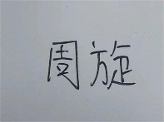__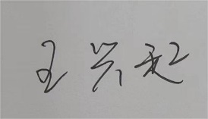  
This change will take effect on: _____2023-6-19______